**Status Report**

**Team 11**

1. **Work done during last week**

* Sprint is not completed as per planned.
* Subscription user story is not finished.
* Search and product quantity user stories are completed.
* Search user story is taken more effort to complete than the estimated effort.
* After January 6th, each member utilized their time for individual report.
* As the user stories like subscription, other stories which are in product backlog like pay option, cash on delivery, live chat are assigned to future sprints.
* The below burndown chart preview the remaining effort after day 10, so there is a 19 hours’ effort remaining in sprint 3.

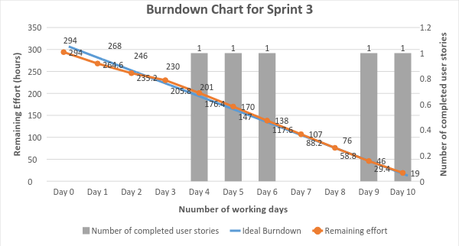

**Figure 1. Burndown chart for sprint 3.**

1. **Issues**

* The main issue faced is search user story taken more effort than estimated because of assignments and vacations efficiency has declined.
* The sprint is not completed as per plan.
* So these non-completed user stories will be transferred to future development.
* As the product is market-on demand, so the product which is completed up to now is provided to investor.
* **Note:** Everyone participated in the project activities and no member is remotely working.